1. Introduction to Autoencoders
An Autoencoder is a neural network used for unsupervised learning that learns to compress input data and then reconstruct it back.
It tries to learn the best internal representation (encoding) of the input.
Basic Idea
Input → Compress → Reconstruct
The model learns a compressed representation of data while keeping the most important information.
Architecture of Autoencoder
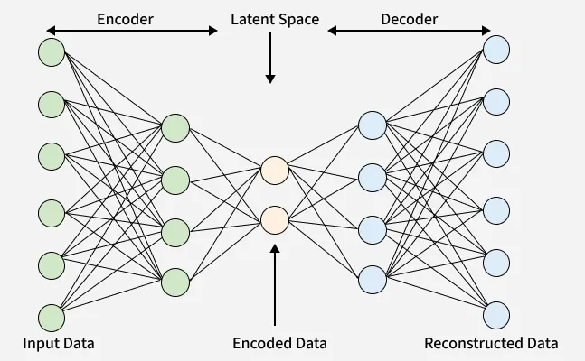
An autoencoder has three main components:
- Encoder
- Latent Space (Bottleneck)
- Decoder
Input Data → Encoder → Latent Representation → Decoder → Reconstructed Output

1. Encoder
It compress the input data into a smaller, more manageable form by reducing its dimensionality while preserving important information. It has three layers which are:
- Input Layer: This is where the original data enters the network. It can be images, text features or any other structured data.
- Hidden Layers: These layers perform a series of transformations on the input data. Each hidden layer applies weights and activation functions to capture important patterns, progressively reducing the data's size and complexity.
- Output(Latent Space): The encoder outputs a compressed vector known as the latent representation or encoding. This vector captures the important features of the input data in a condensed form helps in filtering out noise and redundancies.
2. Bottleneck (Latent Space)
It is the smallest layer of the network which represents the most compressed version of the input data. It serves as the information bottleneck which force the network to prioritize the most significant features. This compact representation helps the model learn the underlying structure and key patterns of the input helps in enabling better generalization and efficient data encoding.
3. Decoder
It is responsible for taking the compressed representation from the latent space and reconstructing it back into the original data form.
- Hidden Layers: These layers progressively expand the latent vector back into a higher-dimensional space. Through successive transformations decoder attempts to restore the original data shape and details
- Output Layer: The final layer produces the reconstructed output which aims to closely resemble the original input. The quality of reconstruction depends on how well the encoder-decoder pair can minimize the difference between the input and output during training.

1.1 Encoder
The encoder compresses the input data into a smaller representation.
Example:
Input image (784 pixels)
→ compressed to
Latent vector (32 features)
Mathematically:
Encoder function:
$$z=f(x)$$
where
- $x$= input data
- $z$= encoded representation

1.2 Latent Space (Bottleneck Layer)
This is the compressed representation of the data.
It forces the model to learn the most important features.
Example:
Original data: 784 features
Latent representation: 32 features

1.3 Decoder
The decoder reconstructs the original input from the compressed representation.
Mathematically:
$$x^{'}=g(z)$$
where
- $z$= encoded representation
- $x^{'}$= reconstructed output

1.4 Loss Function
During training an autoencoder’s goal is to minimize the reconstruction loss which measures how different the reconstructed output is from the original input. The choice of loss function depends on the type of data being processed:
- Mean Squared Error (MSE): This is commonly used for continuous data. It measures the average squared differences between the input and the reconstructed data.
- Binary Cross-Entropy: Used for binary data (0 or 1 values). It calculates the difference in probability between the original and reconstructed output.
During training the network updates its weights using backpropagation to minimize this reconstruction loss. By doing this it learns to extract and retain the most important features of the input data which are encoded in the latent space.

Autoencoders minimize reconstruction error.
Common losses:
Mean Squared Error (MSE)
$$Loss=∣∣x-x^{'}∣∣^{2}$$
where
- $x$= original input
- $x^{'}$= reconstructed output

1.5 Simple Example
Suppose we have an image dataset.
Input:
28 × 28 image → 784 pixels
Encoder compresses:
784 → 128 → 64 → 32
Decoder reconstructs:
32 → 64 → 128 → 784
Output becomes:
Reconstructed Image
The goal is:
Original Image ≈ Reconstructed Image

2. Autoencoders vs Principal Component Analysis (PCA)
Both Autoencoders and PCA are used for dimensionality reduction.
But they work very differently.

2.1 Principal Component Analysis (PCA)
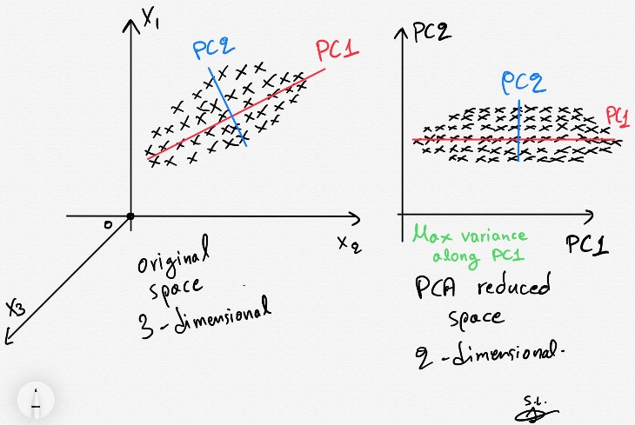
PCA is a linear dimensionality reduction technique.
It finds new orthogonal axes (principal components) that capture the maximum variance.
Mathematically PCA finds:
$$Z=XW$$
where
- $X$= data
- $W$= principal component vectors
- $Z$= reduced representation

2.2 Autoencoder vs PCA Comparison
Feature | PCA | Autoencoder
Type | Statistical technique | Neural network
Learning | Linear | Linear + Nonlinear
Flexibility | Limited | Highly flexible
Architecture | Matrix decomposition | Encoder–Decoder network
Data Type | Numeric data | Images, text, audio
Scalability | Works well for small datasets | Works well for big datasets

2.3 Important Theoretical Result
A linear autoencoder with one hidden layer and MSE loss learns the same subspace as PCA.
But:
Autoencoders can learn nonlinear relationships, PCA cannot.
Example:
If data lies on a curved manifold, PCA fails but autoencoders can capture it.

2.4 Visualization Concept
PCA:
Data → Projection onto new axes
Autoencoder:
Data → Neural network → Compressed representation

3. Types of Autoencoders
There are several types depending on the learning objective.

3.1 Basic (Vanilla) Autoencoder
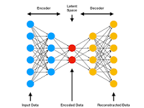
The simplest autoencoder.
Architecture:
Input → Hidden Layer → Output
Goal:
Minimize reconstruction loss.
Example:
784 → 32 → 784
Applications:
- dimensionality reduction
- feature extraction

3.2 Sparse Autoencoder
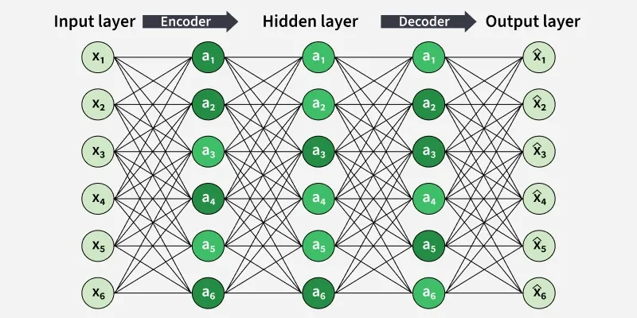
Sparse autoencoders enforce sparsity constraints.
Only few neurons activate at a time.
This helps the network learn more meaningful features.
Example:
Most neurons output 0, only few active.
Applications:
- feature learning
- representation learning

3.3 Denoising Autoencoder
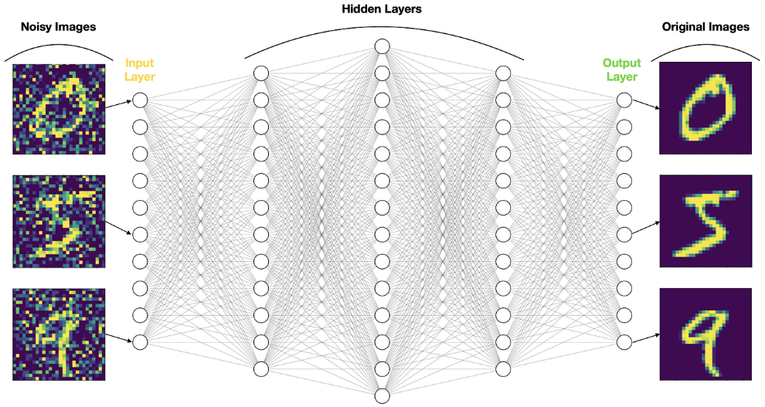
These autoencoders learn to remove noise from corrupted data.
Process:
- Add noise to input
- Train network to reconstruct original clean input
Example:
Noisy Image → Autoencoder → Clean Image
Applications:
- image denoising
- audio cleaning
- signal processing

3.4 Contractive Autoencoder

These autoencoders add a regularization penalty.
Goal:
Make the model robust to small input changes.
Loss includes:
Reconstruction Loss + Jacobian Penalty
Applications:
- robust feature learning
- manifold learning

3.5 Variational Autoencoder (VAE)
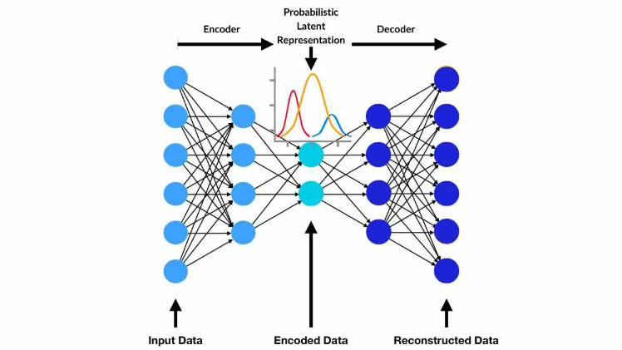
Very important modern architecture.
Instead of learning single latent representation, VAE learns a probability distribution.
Encoder outputs:
Mean (μ)
Variance (σ)
Then we sample:
$$z∼N(μ,σ)$$
Applications:
- generative models
- image generation
- anomaly detection
Example:
Generating new faces or digits.
• Autoencoders (VAE) → older generation approach
• GANs → intermediate stage
• Diffusion Models → current SOTA (DALL·E, Imagen, Sora, Veo)

3.6 Convolutional Autoencoder
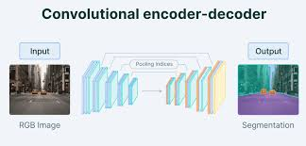
Used for images.
Instead of dense layers, it uses CNN layers.
Architecture:
Image → Conv Layers → Latent Space → Deconv Layers → Reconstructed Image
Applications:
- image compression
- super resolution
- denoising

4. Applications of Autoencoders
Autoencoders are widely used in deep learning applications.

4.1 Dimensionality Reduction
Autoencoders reduce data dimensions similar to PCA but better for nonlinear data.
Example:
1000 features → 50 latent features
Used in:
- visualization
- preprocessing for ML models

4.2 Image Compression
Autoencoders can compress images.
Example:
Original Image → 784 pixels
Compressed → 32 values
Used in:
- storage optimization
- transmission

4.3 Image Denoising
Denoising autoencoders remove noise from images.
Example:
Noisy MRI scan → Clean MRI scan
Used in:
- medical imaging
- satellite imagery

4.4 Anomaly Detection
Autoencoders learn normal patterns.
If reconstruction error is high → anomaly.
Applications:
- fraud detection
- network intrusion detection
- manufacturing defect detection

4.5 Recommendation Systems
Autoencoders can be used to learn user preference representations.
Example:
User-item matrix → compressed representation → predicted ratings
This is related to your RBM recommendation system work.

4.6 Feature Learning
Autoencoders automatically extract important features.
Example:
For images:
edges
textures
patterns
These features help improve classification models.

4.7 Data Generation
Using Variational Autoencoders (VAE).
Applications:
- image synthesis
- drug discovery
- speech generation

5. Real-World Industry Applications
Industry | Application
Healthcare | MRI denoising
Finance | Fraud detection
Manufacturing | Defect detection
Cybersecurity | Intrusion detection
E-commerce | Recommendation systems
Autonomous vehicles | Sensor data compression

6. Simple Autoencoder Example (Python)
Example using TensorFlow/Keras.
from tensorflow.keras.layers import Input, Dense
from tensorflow.keras.models import Model
input_dim = 784
input_layer = Input(shape=(input_dim,))
encoded = Dense(128, activation='relu')(input_layer)
encoded = Dense(32, activation='relu')(encoded)
decoded = Dense(128, activation='relu')(encoded)
decoded = Dense(784, activation='sigmoid')(decoded)
autoencoder = Model(input_layer, decoded)
autoencoder.compile(optimizer='adam', loss='mse')
Training:
autoencoder.fit(X_train, X_train,
epochs=50,
batch_size=256)
Note:
Input and output are same.

7. Key Interview Points
Important points interviewers ask:
- Autoencoder is unsupervised learning.
- Goal is reconstruction of input.
- Consists of Encoder + Latent Space + Decoder.
- Used for dimensionality reduction and feature learning.
- Linear autoencoder ≈ PCA.
- Can learn nonlinear relationships.
- Types include:
  - Sparse Autoencoder
  - Denoising Autoencoder
  - Variational Autoencoder
  - Convolutional Autoencoder

Efficient Representations in Autoencoders
Constraining an autoencoder helps it learn meaningful and compact features from the input data which leads to more efficient representations. After training only the encoder part is used to encode similar data for future tasks. Various techniques are used to achieve this are as follows:
- Keep Small Hidden Layers: Limiting the size of each hidden layer forces the network to focus on the most important features. Smaller layers reduce redundancy and allows efficient encoding.
- Regularization: Techniques like L1 or L2 regularization add penalty terms to the loss function. This prevents overfitting by removing excessively large weights which helps in ensuring the model to learns general and useful representations.
- Denoising: In denoising autoencoders random noise is added to the input during training. It learns to remove this noise during reconstruction which helps it focus on core, noise-free features and helps in improving robustness.
- Tuning the Activation Functions: Adjusting activation functions can promote sparsity by activating only a few neurons at a time. This sparsity reduces model complexity and forces the network to capture only the most relevant features.

